
A

Practical

Assignment
On

New

Age

Life

Skills

Bachelor

of Technology

in

Computer

Science

1
^{st}

SEM

RUNGTA

INTERNATIONAL

SKILLS

UNIVERSITY

SESSION:

2025
-
26

Submitted

By:
-

Nihal Sakre

M
s. Harshali Vaishnaw

Student

name

)
Lecturer
(

Ref

No.

:
-

10884

Submitted

To:

RUNGTA

INTERNATIONAL

SKILLS
UNIVERSITY,CG

SCHOOL

OF

INFORMATION

TECHNOLOGY


INDEX

S.No | Name Of Practical |  | Submisson Date | Remark
1. | Design a professional resume using templates. |  | 26-12-2025
2. | Create a Career Oriented Presentation with 7 slides using transitions and animations. |  | 26-12-2025
3. | Create a social media poster for “DIGITAL AWARENESS WEEK” using canva. |  | 26-12-2025
4. | Compose & send a professional email with an attachment as “you are applying for an internship, send email to HR with your resume attached”. |  | 26-12-2025
5. | Design a complete Google Form survey and analyze responses.  - Create a Google Form titled “Student Attendence Report”.  - Include the following question types:  - 5 MCQs  - 1 Rating scale (1–5)  - 1 Short answer  - 1 Checkbox question  - Customize the theme (header image + color).  - Share the form link with 5 friends and collect responses.  - Generate charts from responses and take screenshots of the analysis page. |  | 26-12-2025
6. | Demonstrate identity.  a)  b)  c) | the creation and management of your digital  Create a social media profile (LinkedIn preferred).  Add a profile photo, short bio, skills, and education details.  Create a simple post about “My Learning  Journey in Digital Literacy.” | 26-12-2025

d) Change your privacy settings to:
- Who can see your posts.
- Who can message you
7. | Using Google Drive or OneDrive:  - Create a new folder named “Unit 3 Practical Work”.  - Upload 3 different files (PDF, image, document).  - Organize them in subfolders: Notes, Images, Assignments.  - Share the main folder with your teacher with View Only permission. | 26-12-2025
8. | Identify one real phishing email : A final-year student, Aman, receives a LinkedIn message saying:  “You are shortlisted for a Remote Software Developer role at Google.  Salary: ₹18 LPA.  Pay ₹2,499 as verification fee.  Limited seats. Pay now to confirm.”  ANSWER THE QUESTIONS :-  - What type of cybercrime is happening here?  - List 3 red flags that show it is a scam?  - What should he do to verify if a job offer is real? | 26-12-2025
9. | Create a Google Form Quiz with the following requirements:  - Convert the form into a Quiz mode with automatic grading.  - Add 5 MCQ questions, each carrying 2 marks.  - Add 1 short answer question that requires manual evaluation.  - Turn ON the setting:  - Limit to 1 response  - Shuffle question order  - Release marks after manual review  - Add a timer add-on (like form presenter) and set up a 10-minute time limit.  - Finally, send the quiz link and view the response | 26-12-2025

 | summary.
10. | Ask ChatGPT OR Google Gemini to generate a 100–120 word paragraph on:  “Is online learning better than offline learning for college students?”  - Run the AI-generated text through Grammarly and any plagiarism-check tool.  - Now manually search online to check if similar sentences exist on blogs or articles.  - Identify 2–3 biased statements in the AI answer, such as:  - Over-generalizations  - One-sided opinions  - Unproven claims  - Rewrite the entire paragraph in a neutral and balanced way, using AI only for grammar suggestions.  - Submit 3 screenshots:  - Plagiarism check result  - Grammarly suggestion page  - Original AI paragraph vs your rewritten unbiased version | 26-12-2025
11. | To compare AI-generated content with student-created content and understand limitations of AI.  - Write a 100–150 word paragraph on the topic:  “Will AI replace jobs or change them?” (This must be written by the student.)  - Ask any AI tool (ChatGPT/Gemini/Copilot) to write the same topic.  - In your practical copy, create a Comparison Table with the headings:  - Human-Generated Content  - AI-Generated Content | 26-12-2025
12. | Create a new NotebookLM project titled: “My Chapter  Revision Notes.” | 26-12-2025

- Upload multiple sources (any 2) such as:
  - PDF notes
  - Web articles iii. Text copied into NotebookLM
- Ask NotebookLM to:
  - Create a combined study guide using all sources.
  - Generate flashcards for quick revision.
  - Create a concept map or explanation of the topic.
- Manually check for:
  - Any incorrect facts
  - Repeated information iii. Missing important points
- Attach 3 screenshots from NotebookLM:
  - Combined study guide
  - Flashcards iii. Concept map / explanation
13. | Create a complete Student Result Management workbook.  - Create a new workbook with 3 sheets renamed as:  - Student_Data  - Marks_Analysis  - Charts  - In Student_Data, enter a list of 15 students with: Name, Roll No, Class, City, Subject1, Subject2, Subject3.  - Use Flash Fill to split “Full Name” into “First Name” and “Last Name”.  - Use Find & Replace to replace city name “Delhii” with correct “Delhi”.  - Use IF function to calculate Pass/Fail (Pass = total ≥ 120).  - Use COUNTIF to find how many students belong to “Delhi”.  - Use AVERAGE, MAX, MIN to analyze marks in the Marks_Analysis sheet. | 26-12-2025

- On the Charts sheet, create:
i. A Bar Chart showing marks of any one subject. ii. A Pie Chart showing percentage of pass vs fail.
- Apply Conditional Formatting to highlight marks < 40 in red.
- Convert the table into a formatted Excel Table.
14. | Build a workbook for managing and analyzing sales data of a small store.  - Create a workbook with sheets:  - Store_Sales  - Summary  - Charts  - Import a CSV sales file (or create a sample table) containing:  Date, Product, Category, Quantity, Price, Total Sales.  - Use Sort (A→Z, Z→A) to organize products by name and category.  - Apply Filter to view only “Electronics” category.  - Use SUMIF to find total sales for a selected product (e.g., “Headphones”).  - Use LEFT, RIGHT, MID to extract:  - First 3 letters of the product name  - Last 2 letters of the category  - Find the highest and lowest sales value using MAX/MIN.  - Prepare a monthly sales summary in the Summary sheet using AVERAGE & SUM.  - Create a Line Chart of month-wise total sales in the Charts sheet. | 26-12-2025

 | j) Apply sheet protection so data cannot be edited accidentally.
15. | Create a complete personal financial planner workbook.  - Create and rename sheets as:  - Expenses  - Budget  - Charts  - Enter at least 20 rows of expense data:  Date, Category, Expense Detail, Amount, Payment Method.  - Use Data Validation dropdown to create a category list (Food, Travel, Fees, Shopping, Other).  - Use Remove Duplicates on the Category column if repeated incorrectly.  - Use SUMIF to calculate total spending for each category.  - In the Budget sheet, create the monthly budget and compare with actual expenses using:  Difference = Budget – Actual (formula required)  - Highlight expenses above ₹2000 using Conditional Formatting.  - Create:  i. A Pie Chart showing category-wise spending ii. A Bar Chart comparing Budget vs Actual  - Use Flash Fill to separate date into Day / Month / Year if needed. Also explain its detail  - Save worksheet in Page Layout view and adjust print area. | 26-12-2025

Practical 1 Design a Professional Resume

Aim
To design a professional resume using online templates.
Objectives
- To understand professional formatting of resumes
- To identify key resume components
- To export resume in PDF format

Materials Required
- Computer with internet
- Canva / MS Word / Google Docs

Procedure

Open the Resume-Designing Application
Start by launching Canva, Google Docs, or MS Word on your computer.

○ If using Canva, log in with your account and go to the Templates section.

○ If using Google Docs, open a new document through Google Drive.

○ If using MS Word, open the application and select “New Document.”

2. Browse and Select an Appropriate Resume Template
Navigate to the resume template section. Browse through various designs and choose a template that matches a professional look, preferably clean, simple, and easy to read.

○ Canva offers a wide range of modern templates.

○ Google Docs provides basic but neat resume layouts.

○ MS Word includes both modern and classic templates.

3. Enter Personal Information
Replace the sample text in the template with your personal details, such as:

○ Full Name

○ Contact Number
○ Email Address

○ Address (optional)

○ LinkedIn or portfolio links (if applicable)
Ensure the information is accurate and formatted consistently.

4. Add Academic Details
Insert your educational background in the provided section of the template. Include:

○ Course/Program Name

○ Institution Name

○ Duration (Year of study)

○ Grades or CGPA (if required)
Arrange information in reverse chronological order (most recent first).

5. Write a Career Objective
Add a short, clear career objective highlighting your goals, strengths, and professional aspirations. Keep it concise (2–3 lines) and tailored to the field you are applying for.

6. Include Skills and Achievements
Create a section for skills, both technical and soft skills. Examples:

○ Technical skills (e.g., MS Office, programming languages)

○ Soft skills (e.g., communication, teamwork)
Add any academic achievements, certificates, awards, or projects relevant to your profile.

7. Format the Resume Professionally
Adjust the text formatting to ensure clarity and readability:

○ Use headings for each section (e.g., Education, Skills, Objective).

○ Use bullet points to list items cleanly.

○ Maintain consistent font style, size, and alignment throughout.

○ Ensure proper spacing and margins for a neat layout.
Review the resume for grammatical correctness and visual balance.

8. Preview and Make Final Adjustments
Scroll through the entire resume to check layout alignment, spacing, colors, and text placement.
Make sure the document looks uniform and professional before exporting.

9. Export the Resume in PDF Format
Once the final layout is ready, export or download the document as a PDF file, which preserves formatting.

○ In Canva, click Download → PDF Print.

○ In Google Docs, go to File → Download → PDF Document.

In MS Word, select File → Save As → PDF.

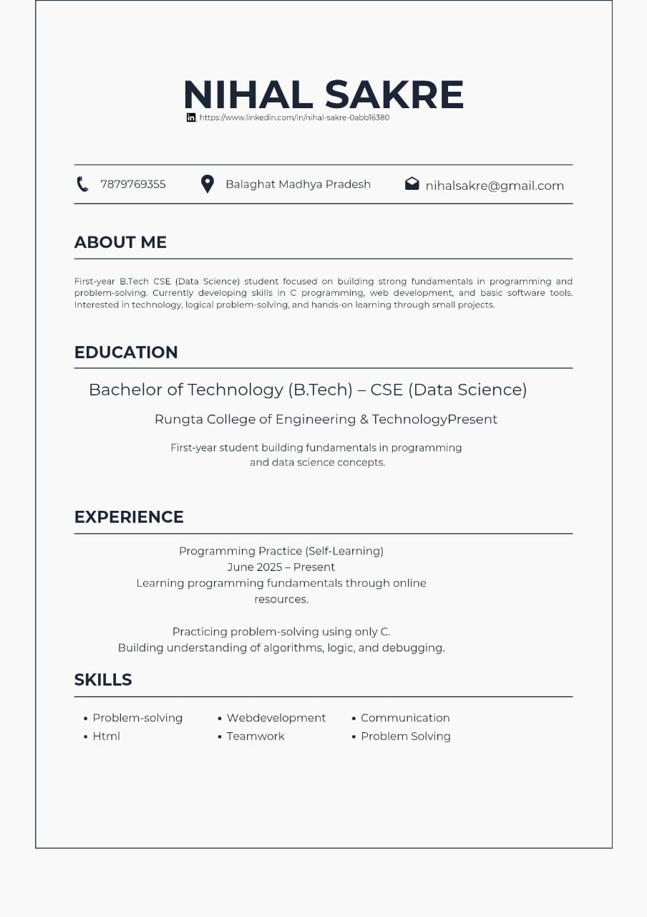

Practical 2
Career-Oriented Presentation

Aim
To create a career presentation using slides, transitions, and animations.
Objectives
- To design a multi-slide professional presentation
- To apply transitions and animations

Materials Required
- PowerPoint or Google Slides

Procedure

Open a blank presentation
Launch PowerPoint/Google Slides and select the option to create a new blank presentation. This opens a fresh workspace where you will design your slides.

Create a title slide
Insert a title slide layout and add the presentation title along with your name or subtitle. Ensure the title is clear, readable, and visually centered on the slide.

Add minimum 7 slides
Use the “New Slide” option to insert at least seven additional slides with appropriate layouts. Each slide should focus on a single topic or idea for clarity.

Insert images, icons, and bullet points
Add relevant images and icons to visually support your content.
Use bullet points to present information in a structured and easy-to-read format.

Apply a theme
Choose a professional theme from the design options available in the software. The theme will automatically set consistent fonts, colors, and backgrounds.

Add transitions and animations
Apply slide transitions for smooth movement between slides.
Add animations to text or images to enhance the presentation without overusing effects.
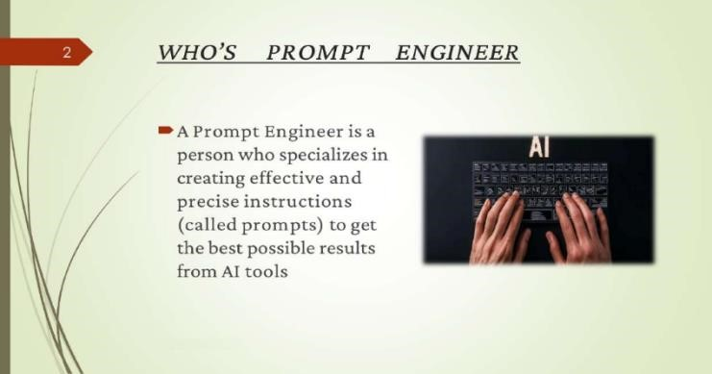

mmmmmmm
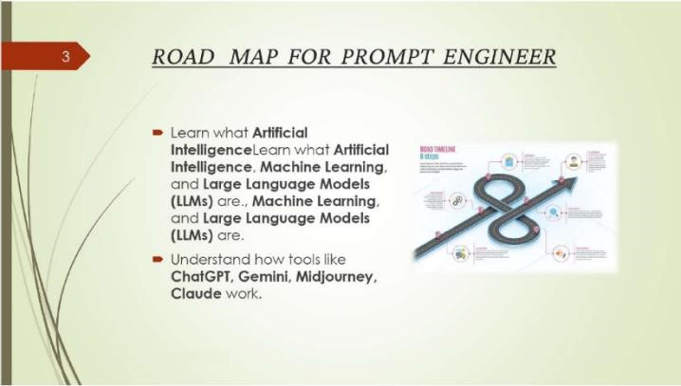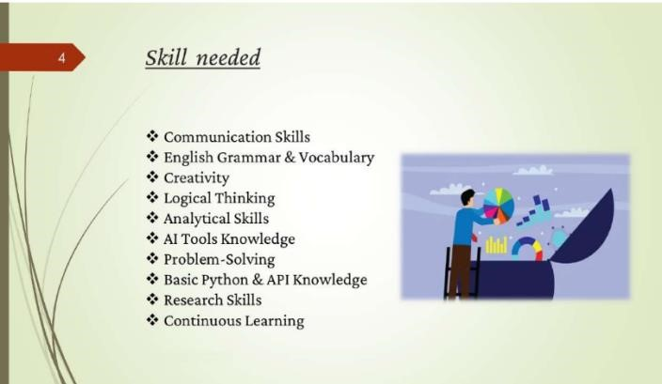
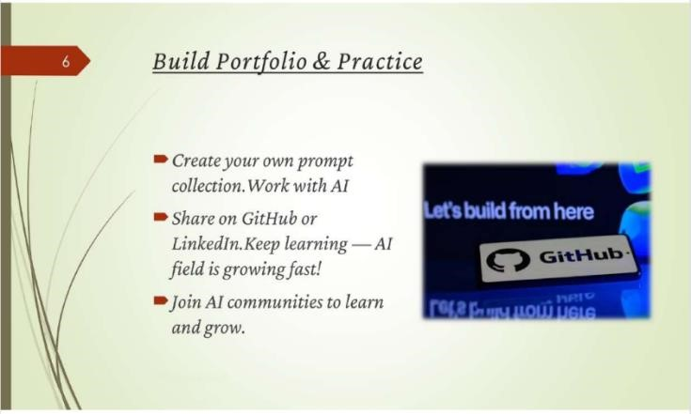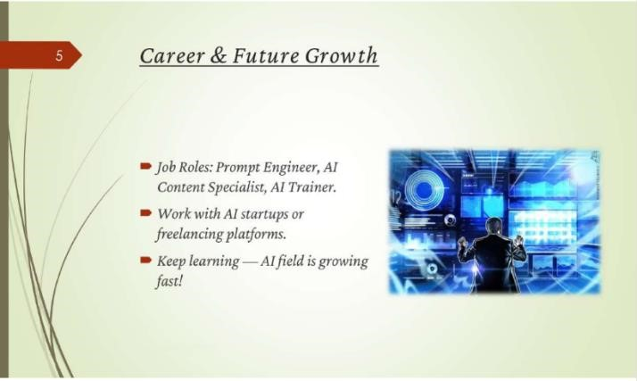

Practical 3
Digital Awareness Poster in Canva

Aim
To design a poster for Digital Awareness Week using Canva.
Objectives
- To apply design tools
- To create a visually appealing poster

Materials Required
- Canva account
- Computer with internet

Procedure

Login to Canva
Open Canva in your browser and sign in using your email or Google account. This gives you access to all templates, design tools, and editing features.

Select poster layout
Search for “Poster” in the template section and choose a suitable layout.
This layout provides a ready-made design structure to begin your poster.

Add “Digital Awareness Week” text
Insert a text box or edit the existing heading and type “Digital Awareness Week.” Adjust the font style, size, and alignment to make the title prominent.

Insert icons and graphics
Go to the “Elements” tab to add icons, shapes, and relevant graphics.
Position them creatively to enhance the visual appeal and message of the poster.

Apply suitable colors
Choose a color theme that matches the topic and improves readability. Use consistent color combinations for background, text, and elements.

Download final poster
Click the “Download” button and select the preferred file type, usually PNG or PDF. Save the poster to your device for printing or sharing



Practical 4
Professional Email (Intership Application)

Aim

To draft and send a professional internship email with attachment.

Objectives
- To compose a professional email
- To attach documents

Materials Required
- Email account
- Resume file

Procedure

Open Gmail
Go to the Gmail website or app and log in with your email account. This opens your inbox where you can create and send emails.

Click Compose
Select the “Compose” button to open a new email window. A blank message box will appear on the screen.

Write subject line
Enter a clear and concise subject that reflects the purpose of the email. This helps the recipient understand the message at a glance.

Write professional message
Type a polite, well-structured message addressing the recipient formally. Keep the tone respectful and include necessary details or requests.

Attach resume
Click the attachment (paperclip) icon and select your resume file from your device. Ensure the resume is in PDF format and properly named.

Send email
Review the email for accuracy and ensure attachments are included.
Click “Send” to deliver the message to the recipient

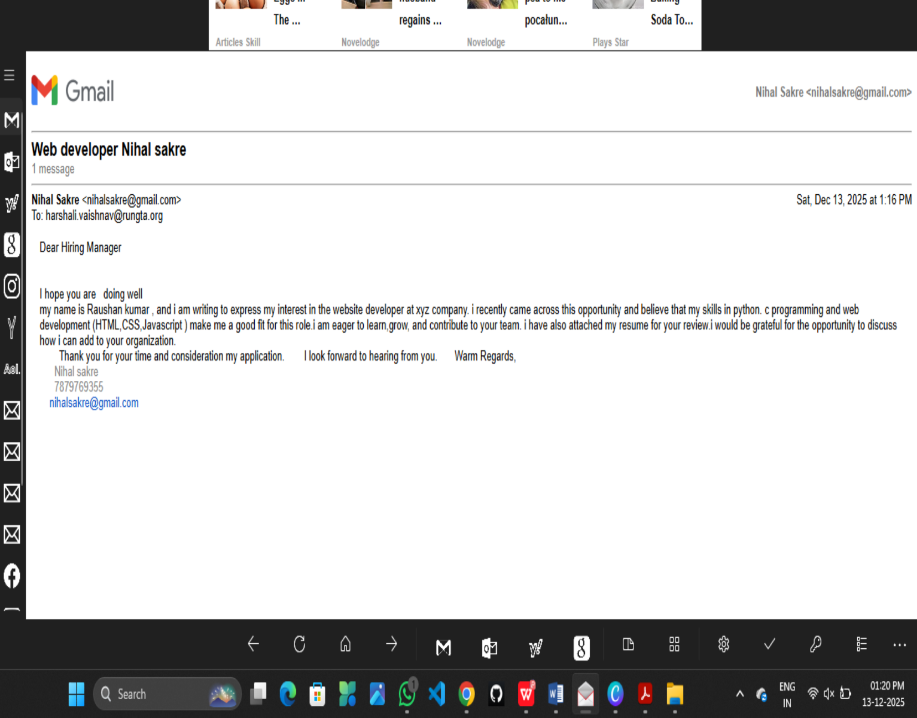

Practical 5 Create Google Form – Attendance Report

Aim
To design a Google Form and analyze responses.
Objectives
- To create form with multiple question types
- To collect sample responses
- To analyze responses

Materials Required
- Google account
- Internet

Procedure

Create new Google Form
Open Google Forms from your Google account and click “Blank Form” to start a new form. This opens an empty form where you can add questions.

Title it “Student Attendance Report”
Enter the title at the top of the form and add a short description if needed. This helps respondents understand the purpose of the form.

Add MCQs, rating, checkbox and short answer
Use the question type menu to insert multiple-choice questions, rating scales, checkboxes, and short-answer fields. Arrange the questions in a logical order for easy response.

Customize theme
Click the Theme icon to change colors, fonts, and header images.
This improves the appearance and makes the form visually appealing.

Share form and collect responses
Use the Send button to share the form via link, email, or QR code. Allow participants to submit their responses through any device.

View summary charts
Go to the Responses tab to see automatic charts and graphs generated by Google Forms. These visual summaries help you quickly analyze the collected data.

Take screenshots
Capture screenshots of the form, responses, and charts for documentation. Save them for use in reports or practical records.
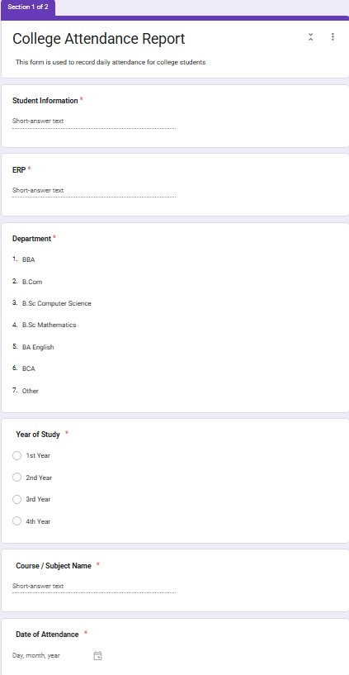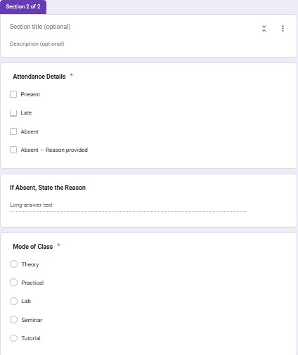

Practical 6 Create Digital Identity – LinkedIn

Aim
To create and modify digital identity using LinkedIn.
Objectives
- To create professional online profile
- To update personal information

Materials Required
- LinkedIn account

Procedure

Create LinkedIn profile
Sign up on LinkedIn using your email and set up a new profile.
This gives you access to professional networking and career-building tools.

Add photo, bio, education
Upload a clear professional photo and write a short bio summarizing who you are. Enter your educational details to complete your basic profile information.

Add skills
Use the “Skills” section to list your technical and soft skills.
Adding relevant skills increases your visibility and strengthens your profile.

Create a simple post
Click “Start a Post” and write a short, meaningful update or introduction. Share it publicly to begin engaging with your professional network.

Change privacy settings
Go to Settings & Privacy to adjust what others can see on your profile.
Modify visibility, contact preferences, and data-sharing options as needed.

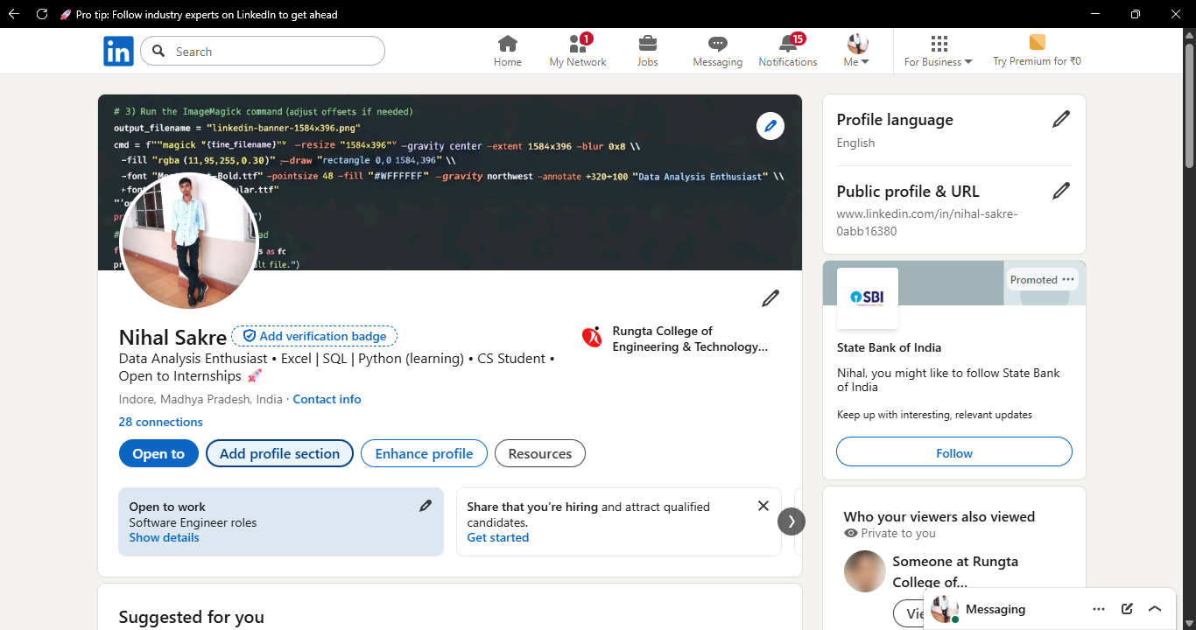

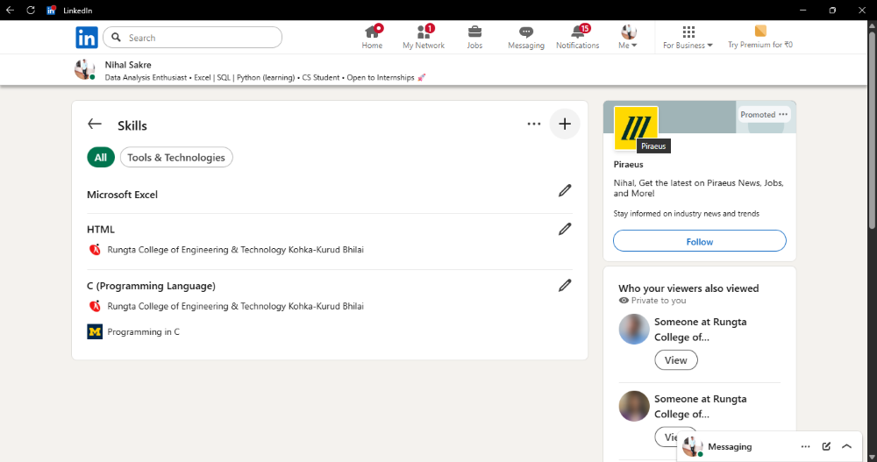

Practical 7
Using Google Drive / OneDrive
Aim

To upload and organize files in cloud storage.
Objectives
- To manage files online
- To share files securely

Materials Required
- Google Drive / OneDrive account

Procedure

1. Create folder “Unit 3 Practical Work”
Open Google Drive or your file manager and create a new folder named “Unit 3 Practical Work.” This folder will store all files related to the practical.

2. Upload documents
Click the Upload option and select the required documents from your device. The files will be saved inside the main folder for easy access.

3. Create subfolders
Inside the main folder, create additional subfolders to categorize your documents. This helps keep your work organized and easy to locate.

4. Share main folder with View only
Right-click the folder, choose Share, and set the permission to View only for others.
This allows people to see the contents but prevents them from editing or deleting files.

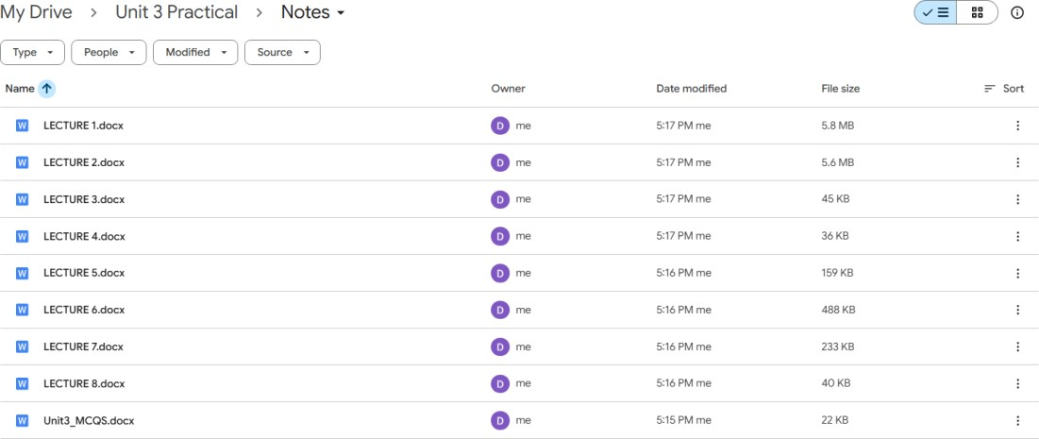

Practical 8
Identify Phishing Attack

Aim
To identify phishing attempts through digital messages.
Objectives
- To detect cybercrime
- To recognize scam elements

Materials Required
- Provided phishing example

Procedure

Read message text
Carefully go through the entire message to understand its content and intent. Make note of any unusual requests or unfamiliar senders.

Identify suspicious elements
Look for spelling errors, urgent demands, unknown links, or too-good-to-be-true offers. These signs often indicate potential scams or malicious intent.

List cybercrime type
Based on the suspicious elements, categorize the message as phishing, fraud, malware attempt, etc. This helps in understanding the nature and threat level of the cybercrime.

Write verification steps
Suggest ways to confirm authenticity, such as checking the sender’s email, contacting the official source, or scanning links. These steps help prevent falling victim to cyberattacks.

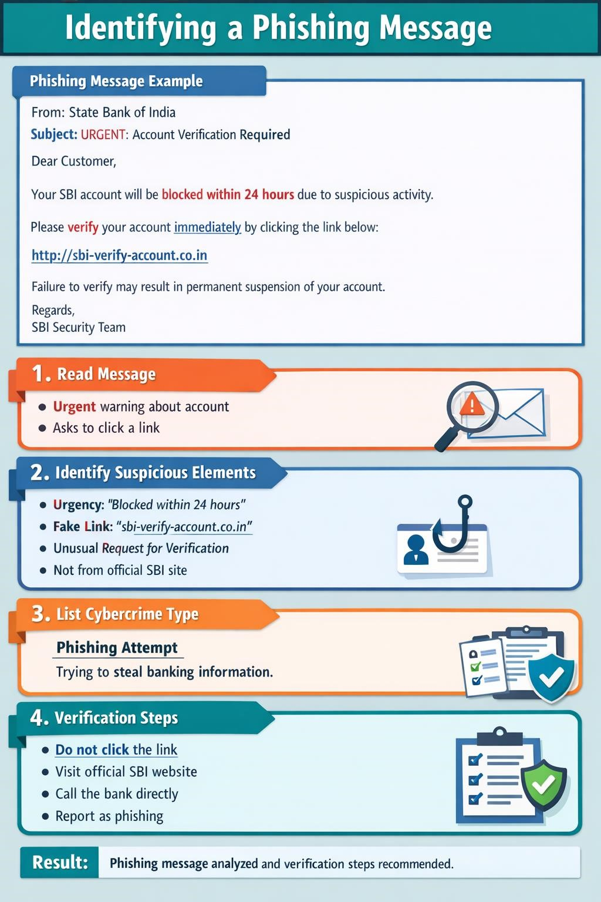

Practical 9

Google Form Quiz with Timer

Aim
To create a quiz with automatic grading and time limit.
Objectives
- To automate quiz assessment
- To use time limit add-on

Materials Required
- Google Forms
- Timer add-on

Procedure

- Create Google Form – Open Google Forms and start a new blank form to set up the structure of your activity.

- Convert to quiz – Enable “Make this a quiz” in the settings so you can assign points and correct answers.

- Add 5 MCQs + 1 short answer – Insert five multiple-choice questions and one short-answer question, customizing options and points.

- Enable 1-response limit – Turn on “Limit to 1 response” so each user can submit the form only once.

- Shuffle questions – Activate the shuffle feature to randomize the order of questions for every respondent.

- Add timer add-on – Install a timer add-on from the Add-ons menu to set and control the quiz duration.

- Send link – Use the “Send” button to generate and share the form link with participants.

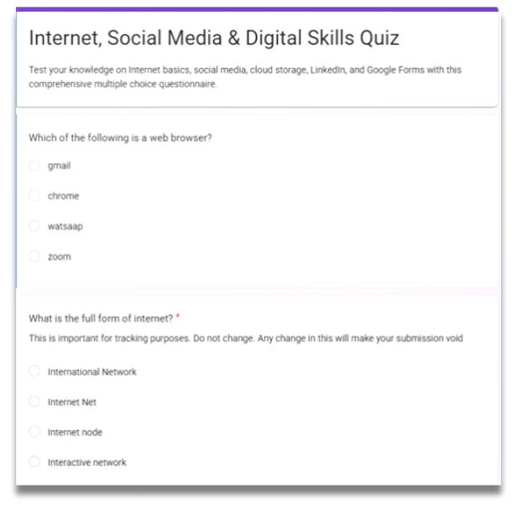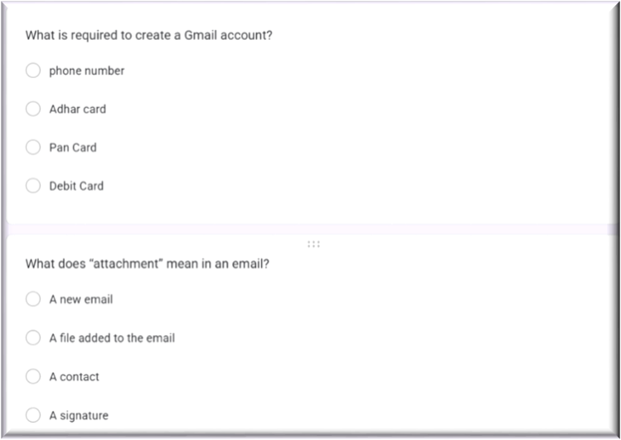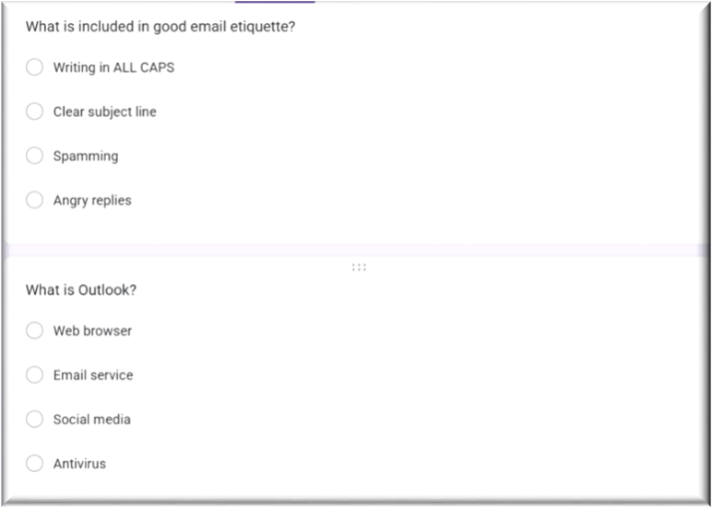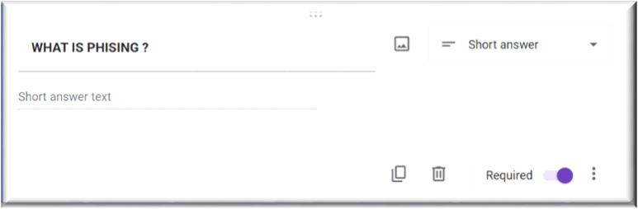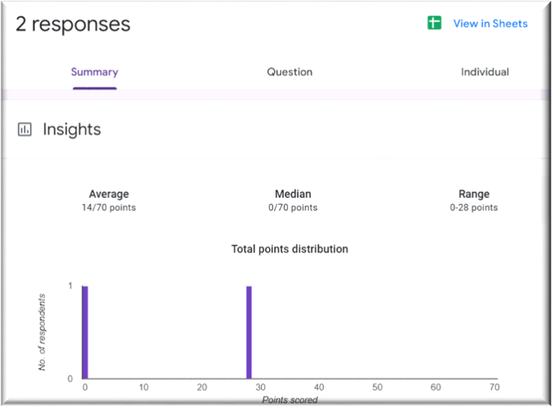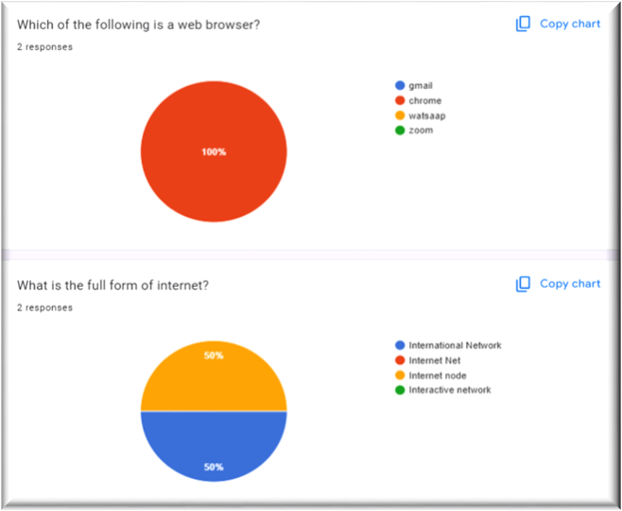

AI Text Bias & Plagiarism

Aim
To analyze AI generated text for plagiarism and bias.
Objectives
- To detect biased statements
- To improve writing

Materials Required
- ChatGPT / Gemini
- Grammarly

Procedure

- Generate paragraph from AI – Use an AI writing tool to produce a clear, coherent paragraph on your chosen topic.

- Check plagiarism – Run the paragraph through a plagiarism checker to ensure originality and proper attribution.

- Check grammar – Review the text with a grammar tool to correct errors in punctuation, spelling, and sentence structure.

- Identify biased statements – Examine the content for subjective language, assumptions, or one-sided viewpoints.

- Rewrite neutrally – Revise the paragraph to remove bias, ensuring the tone is balanced, objective, and fact-based.

Compare AI vs Human Writing

Aim
To compare AI-generated content with student-created content.
Objectives
- To identify difference in writing
- To understand AI limitations

Materials Required
- AI tool

Procedure
- Write paragraph manually – Compose a paragraph yourself using your own ideas, wording, and structure on the selected topic.

- Generate same topic using AI – Use an AI tool to produce another paragraph on the same topic for comparison.

- Create comparison table – Organize both paragraphs side-by-side in a table to compare style, clarity, tone, and content differences.

NotebookLM Project

Aim
To create revision notes using NotebookLM.
Objectives
- To generate study guide
- To create flashcards

Materials Required
- NotebookLM

Procedure
- Create NotebookLM project – Start a new project in NotebookLM to organize your materials and AI-generated outputs in one workspace.

- Upload two resources – Add two documents or sources to the project so the AI can analyze and reference them.

- Generate study guide – Use NotebookLM’s tools to create a structured study guide summarizing key concepts from the uploaded resources.

- Generate flashcards – Automatically produce flashcards that highlight important facts, terms, or ideas for easier review.

- Review accuracy – Carefully check the summaries and flashcards to ensure all information is correct and reflects the original resources.

- Take screenshots – Capture screenshots of the study guide and flashcards to document your work or include them in your submission.

